Assignment No.

PRN:12111038
Name of the Student:Pratik Masani
Roll No.: 21
Branch: E&TC
Division:C
Batch:1

Problem Statement:
1. Implement Student class using following Concepts
All types of Constructors
Static variables and instance variables
Static blocks and instance blocks
Static methods and instance methods

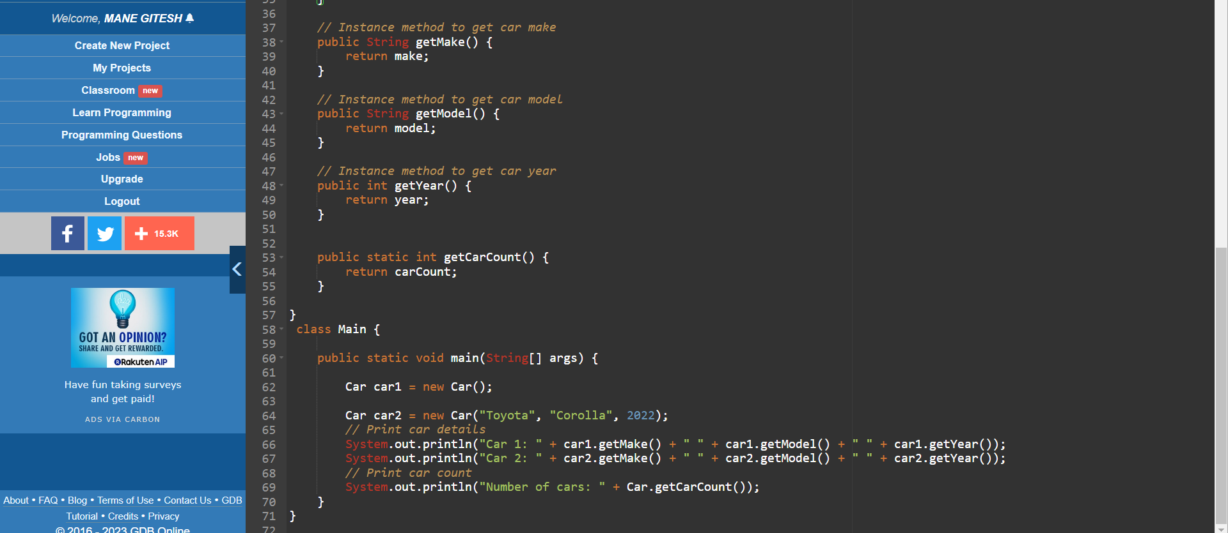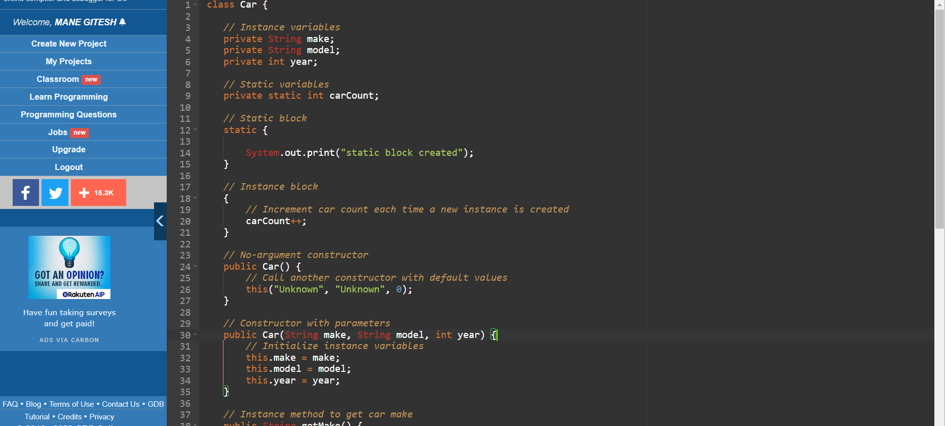
Expected Output:

